Appendix: How to view your W-2 Online
STEP 1:
Open your web browser and go to: http://webadvisor.puc.edu
STEP 2: Click Log In STEP 5: Click on W-2

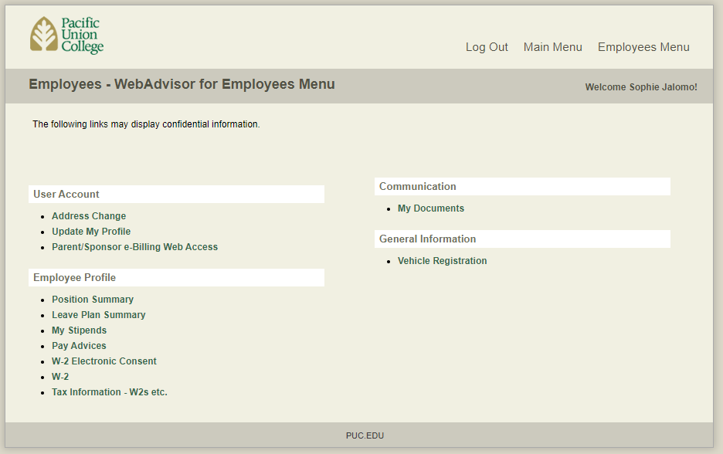
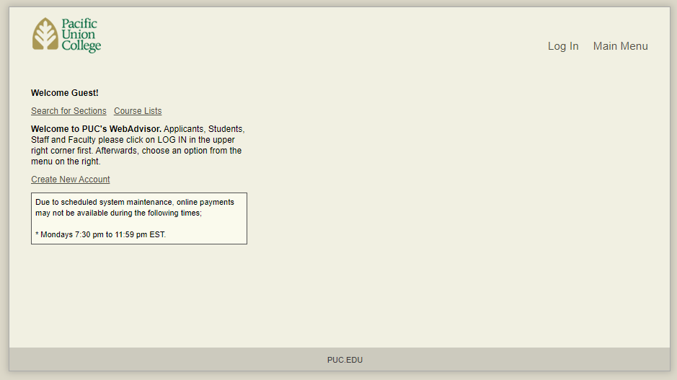

STEP 3: Enter the credentials to your student STEP 6: Click on the year that corresponds
account. This will be the same as your Canvas Login to the W-2 you want to see
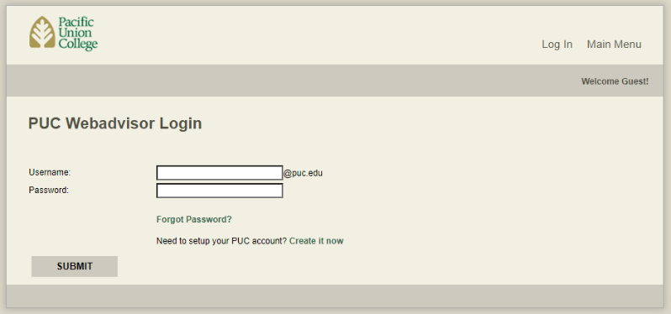
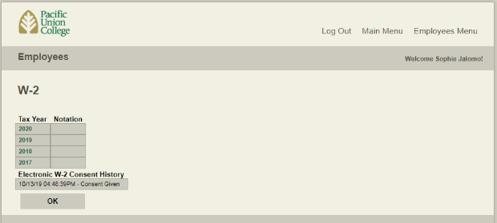
Click Submit W-2 will automatically appear

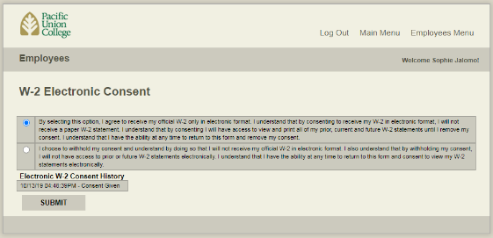
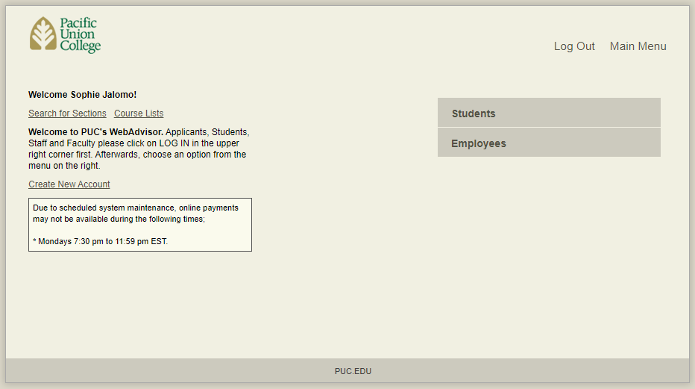
STEP 4: Click Employees If you cannot view your W-2, go back to the Employees Menu and click on W-2 Electronic Consent. Choose the option below and Submit. Go back to Step 6

Questions?
Contact Student Employment / Payroll at
707-965-7198 or stuemployment@puc.edu

