Appendix: How to view your Paystubs Online
STEP 1:
Open your web browser and go to: http://webadvisor.puc.edu
STEP 2: Click Log In STEP 5: Click on Pay Advices

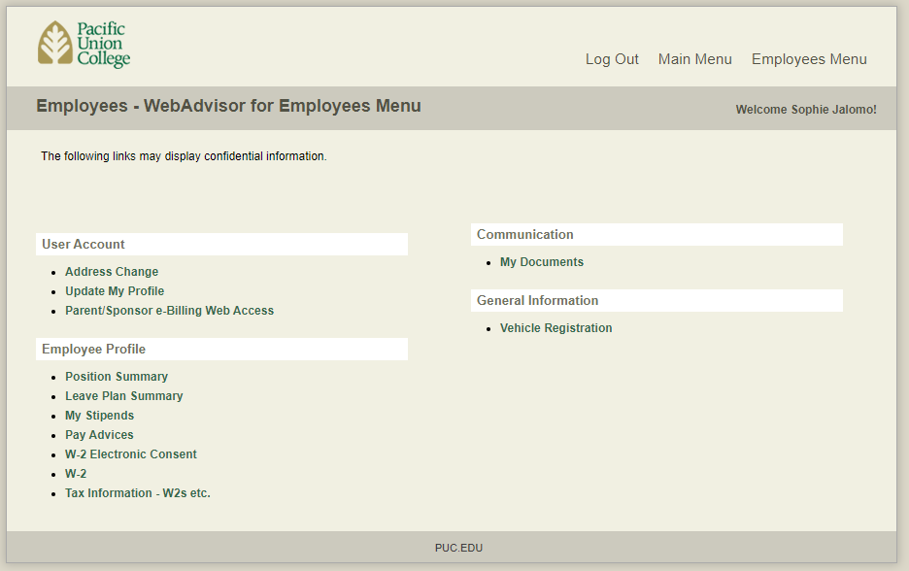
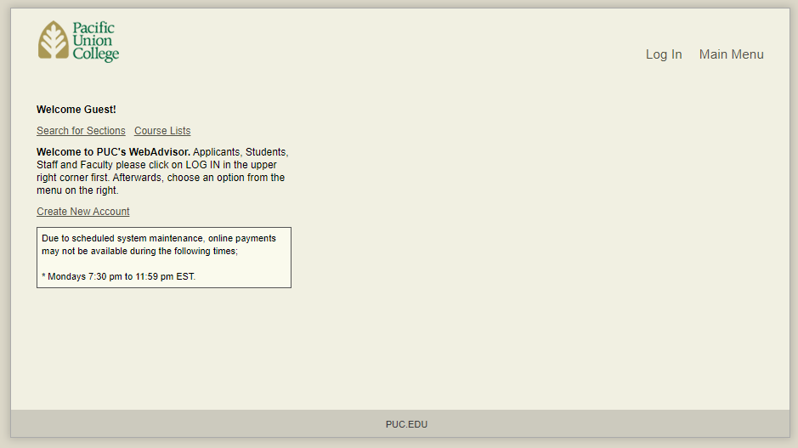

STEP 3: Enter the credentials to your student STEP 6: Click on the date that corresponds
account. This will be the same as your Canvas Login to the advice you want to see
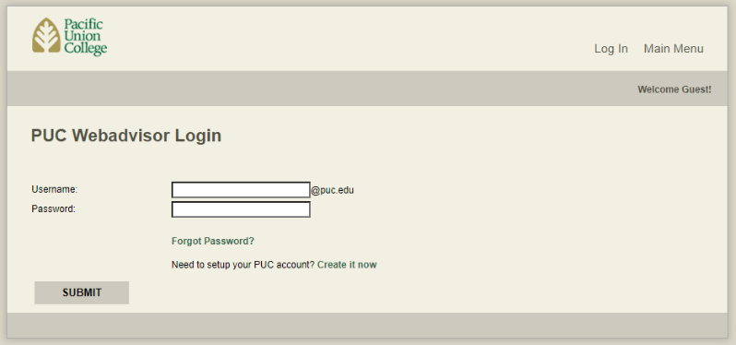
Click Submit Your Advice will automatically appear
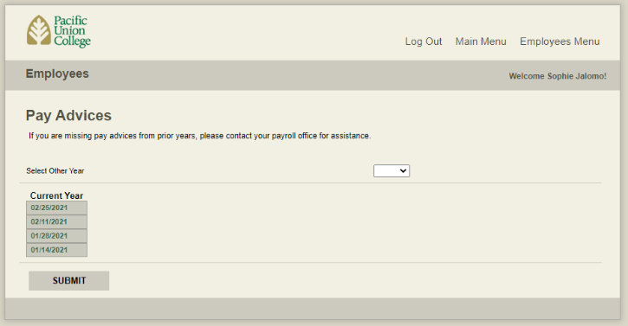

STEP 4: Click Employees
What is on my Pay Advice?
- The number of hours that I worked during the pay period
- My available sick-leave hours
- The total amount that I got paid
- Any tax, tithe, offering, or tuition deductions

Questions?
Call Student Employment/Payroll
at: 707-965-7198

Email us at: stuemployment@puc.edu
